***Mastering Embedded Systems***

Online Diploma

**Project 1**

|  |
| --- |
| Pressure Controlling system. |

**Name: Hisham Elsayed Morsy Youssef**

**Learn in depth profile:** [**https://www.learn-in-depth.com/online-diploma/hisham.elkenany2000%40gmail.com**](https://www.learn-in-depth.com/online-diploma/hisham.elkenany2000%40gmail.com)

# Learn In Depth

Be Professional In Embedded System

Eng. Keroles Shenouda

1. **Project Overview**

* We are required to deliver a pressure controller that informs the crew of a cabin with an alarm when the pressure exceeds 20 bars in the cabin.
* The alarm duration equals 60 seconds.

1. **Method**

* In this project I choose waterfall model due to its simplicity

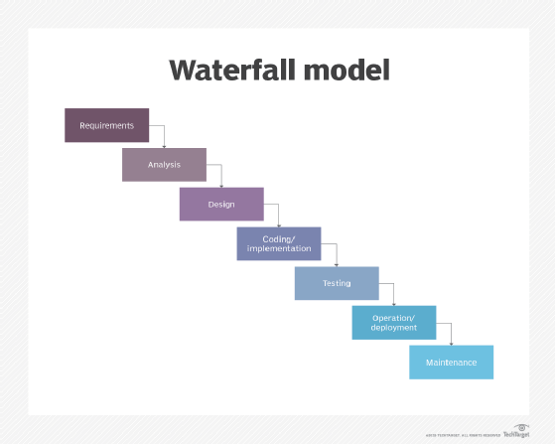

1. **Requirement Diagram**

1. **System Analysis**
   * 1. Use case diagram.

ii)Activity diagram.

1. **Design**

Pressure Reading: 32 (Greater than threshold)

* Alarm ON

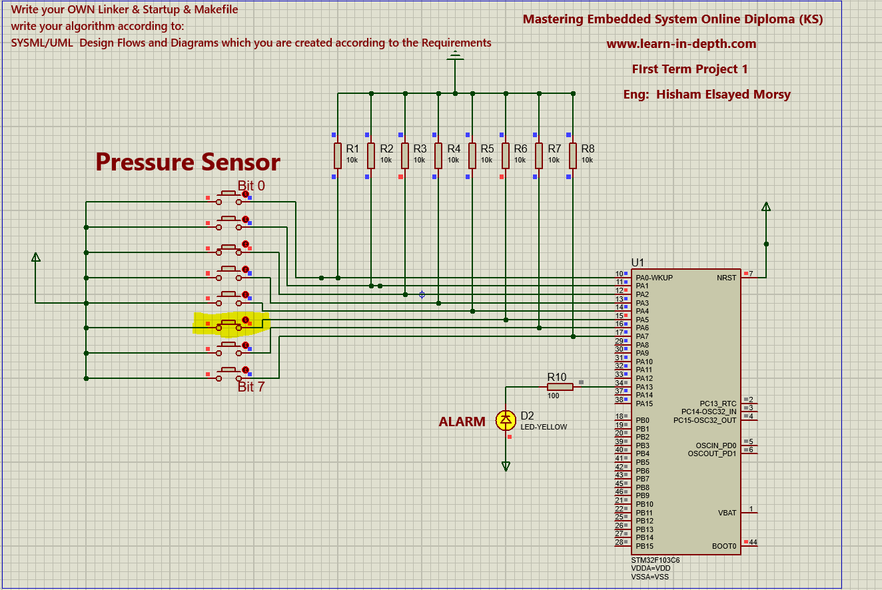

Pressure Reading: 6 (Less than threshold)

* Alarm OFF

